Andrew Stiles
CSD-340
Assignment 1.3

Screenshot of HTML Validation:
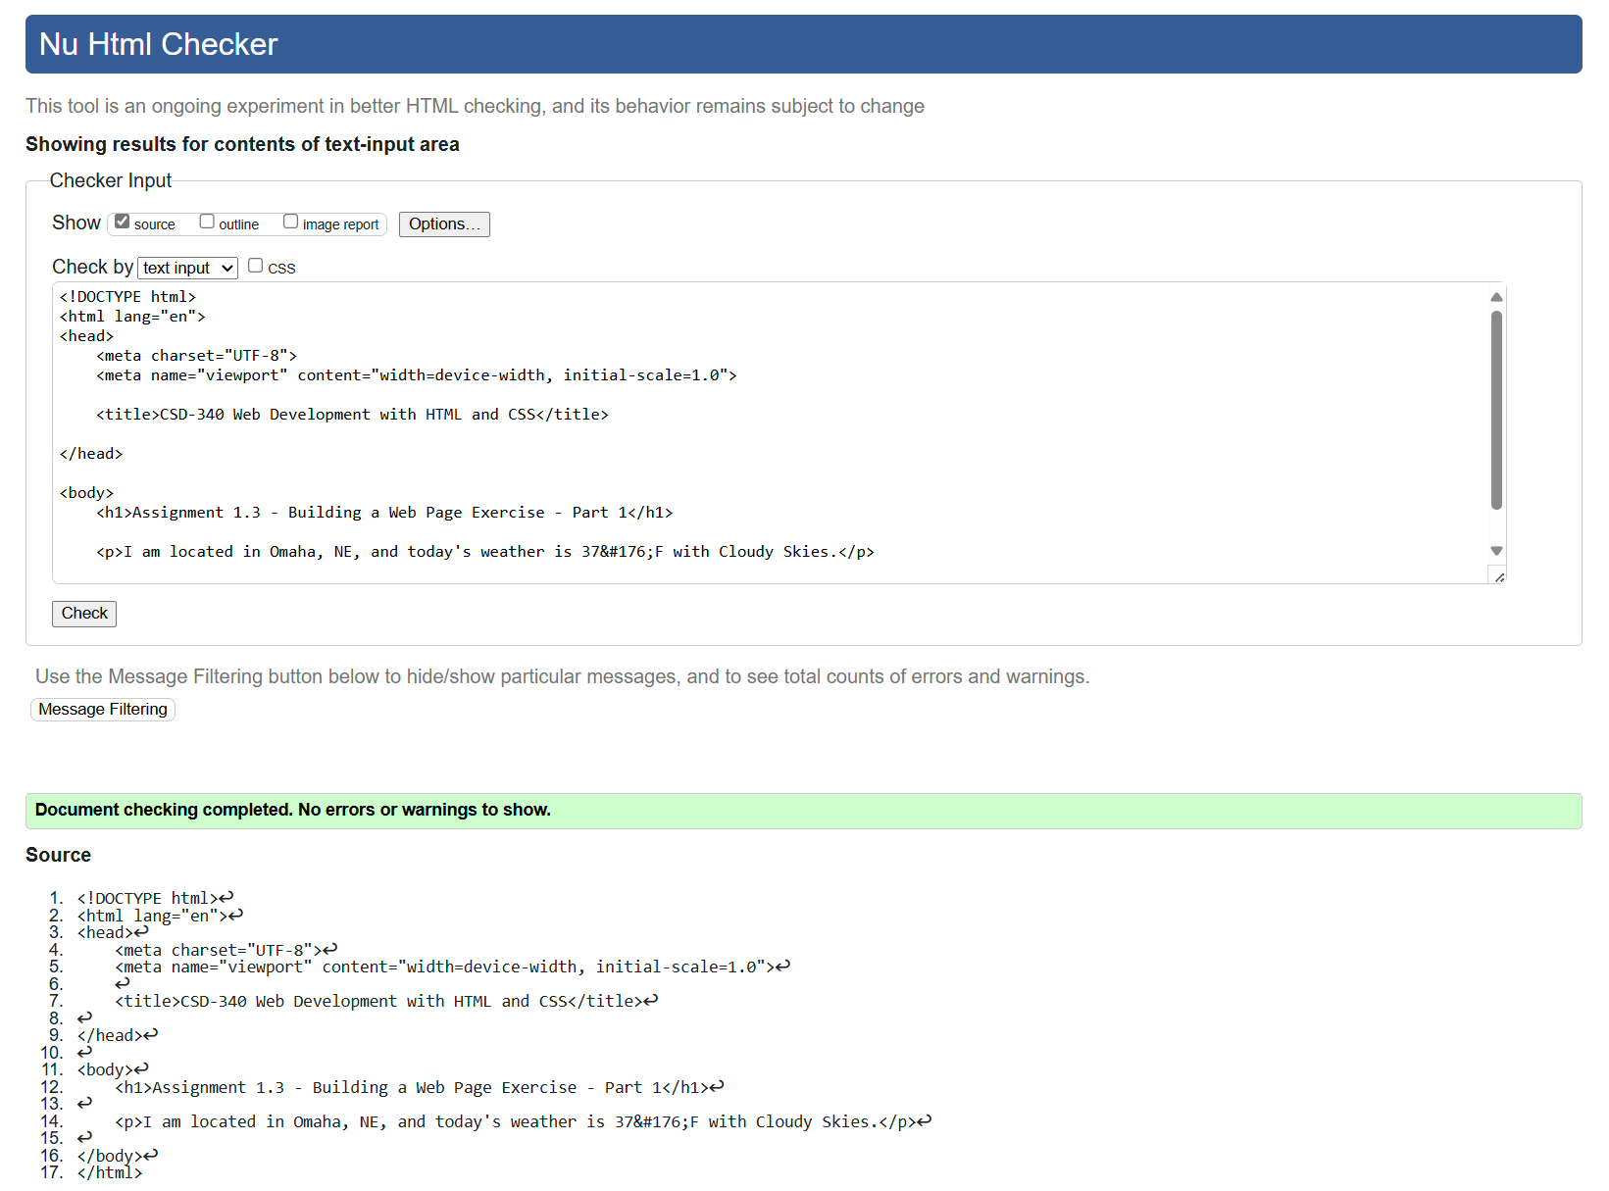

Screenshot of Web Page:
